**Investment Insights Dashboard Project Documentation**

## **1. Project Overview**

**Objective:**

Develop a comprehensive Investment Insights Dashboard using Power BI to analyze and visualize an investment dataset.

**Role:**

Power BI Intern at Cognifyz Technologies

## **2. Tasks and Objectives**

#### **Task 1: Data Exploration and Summary**

**Objective:**

Understand the dataset’s structure and derive key statistics.

**Steps Taken:**

1. **Data Import:** Imported the dataset into Power BI by using the "Get Data" function to ensure all necessary fields were included.
2. **Exploratory Analysis:**
   * Inspected the dataset for structure and data types.
   * Used the Power BI data view to check for any anomalies or missing values.
3. **Calculate Statistics:**
   * Computed average age, investment type percentages, and savings objectives using Power BI’s DAX functions.
4. **Visualization:**

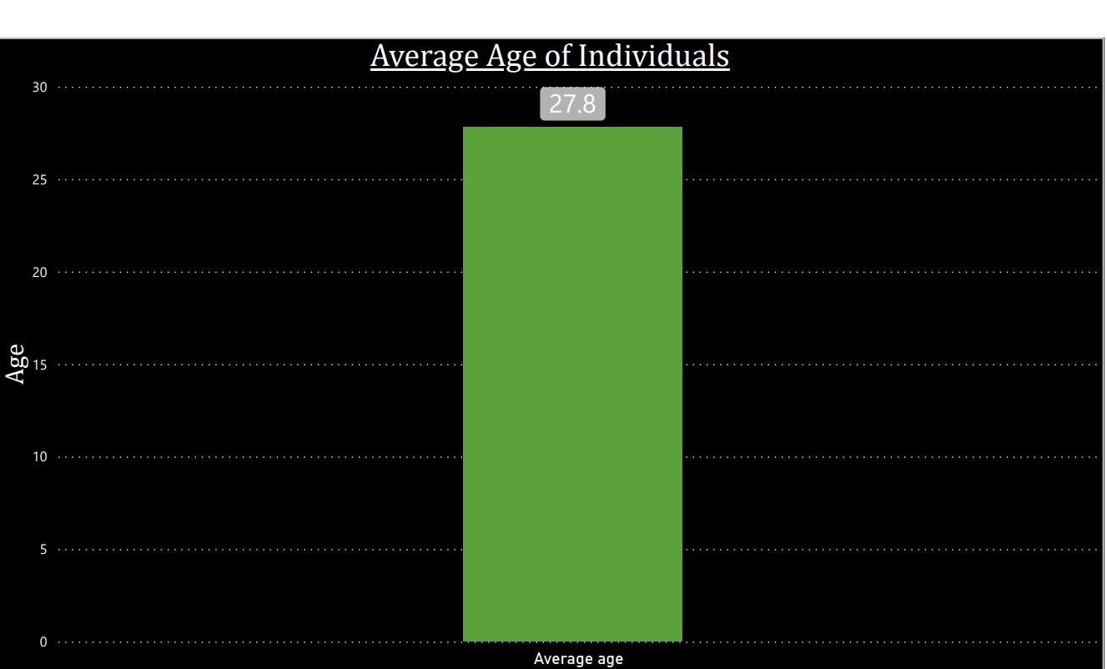

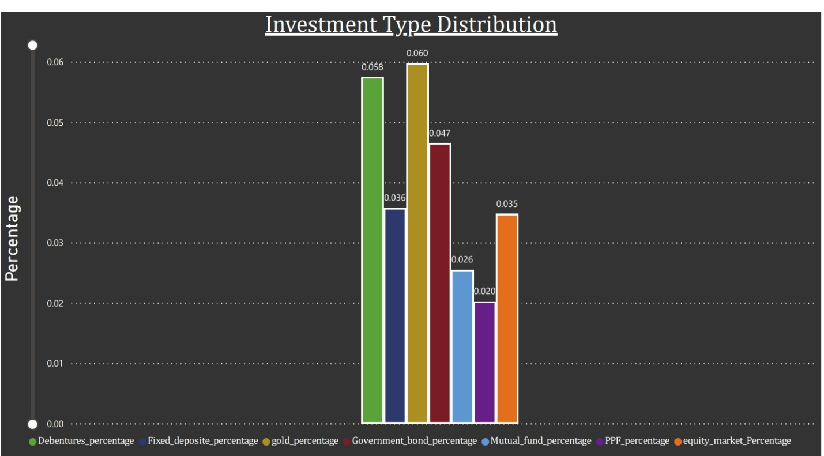

### **Task 2: Gender-Based Analysis**

**Objective:**

Analyze and compare investment preferences by gender.

**Steps Taken:**

1. **Visual Comparison:**
   * Developed charts to display investment choices (equity, mutual funds, bonds) segmented by gender.
   * Used Power BI’s filter and slicer features to enable dynamic comparisons.
2. **Insights:**
   * Analyzed the charts to identify trends and differences in investment preferences between genders.

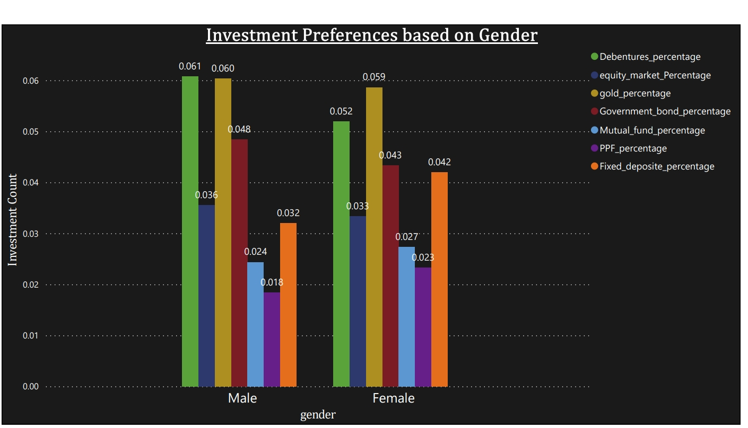

### **Task 3: Objective Analysis**

**Objective:**

Examine the correlation between savings objectives and investment choices.

**Steps Taken:**

1. **Correlation Analysis:**
   * Used Power BI to perform correlation analysis between savings objectives and investment types.
2. **Chart Creation:**

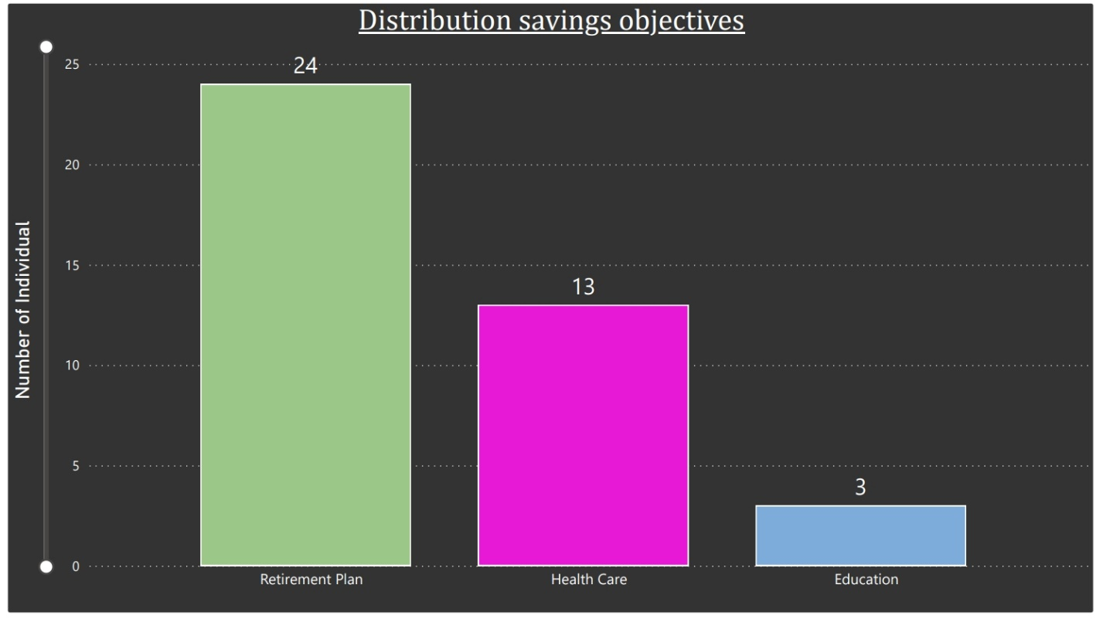

### **Task 4: Investment Duration and Frequency**

**Objective:**

Analyze investment durations and monitoring frequencies.

**Steps Taken:**

1. **Duration Distribution:**
   * Created histograms and bar charts to show the distribution of investment durations.
   * Used Power BI’s time-based visuals for better representation.
2. **Frequency Analysis:**
   * Examined how often investments are monitored and their impact on investment choices.
   * Produced charts reflecting monitoring frequencies and their correlation with investment preferences.

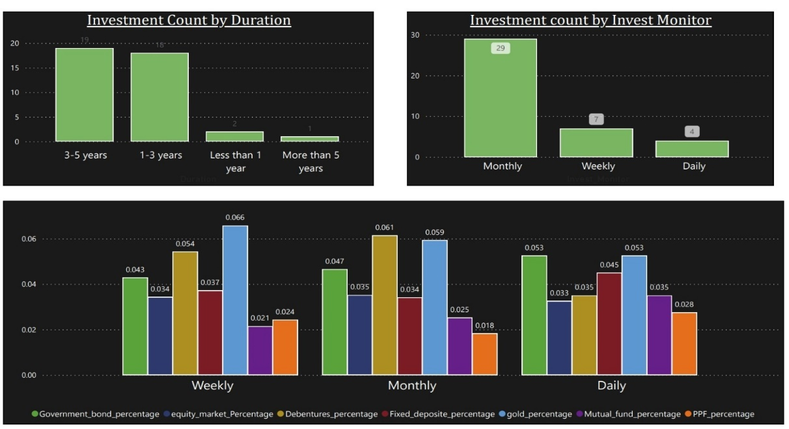

### **Task 5: Reasons for Investment**

**Objective:**

Analyze why individuals invest.

**Steps:**

1. **Trend Analysis:** Identified common trends in investment reasons (e.g., Better Returns, Tax Benefits).
2. **Visualization:**

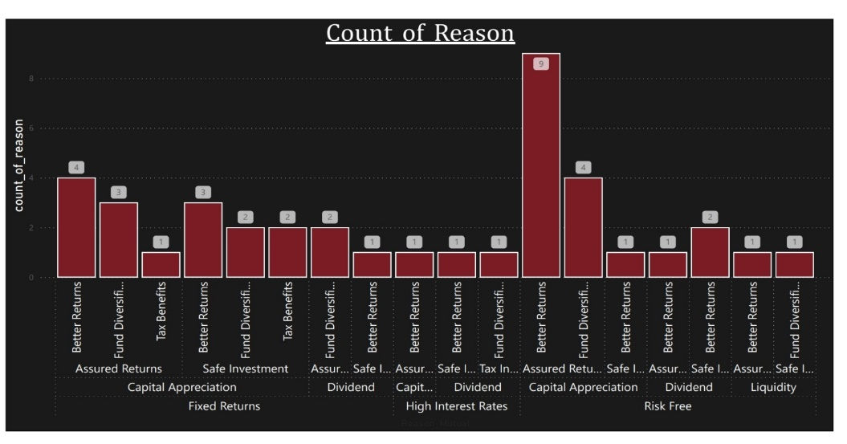

### **Task 6: Source of Information**

**Objective:**

Analyze sources from which individuals gather investment information.

**Steps:**

1. **Source Analysis:** Visualized where individuals get their investment information (e.g., Newspapers, Internet).
2. **Insight Extraction:**

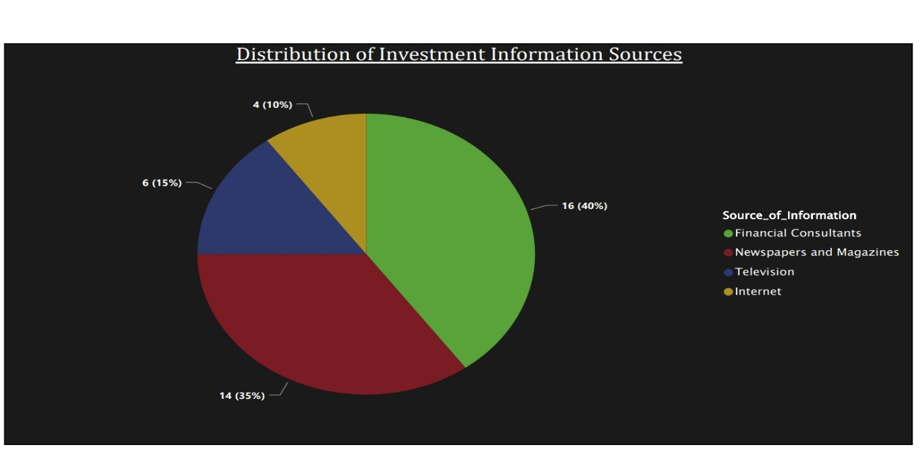

### **Task 7: Combine Insights into a Dashboard**

**Objective:**

Create a comprehensive dashboard presenting all insights.

**Steps:**

1. **Dashboard Design:** Designed an intuitive layout in Power BI.
2. **Incorporate Insights:** Included visualizations from all previous tasks.
3. **Interactivity:** Added interactive elements for data exploration.
4. **Key Findings:** Summarized major insights from the analysis.
5. **Finalization:** Polished the dashboard for a professional appearance and user-friendly experience.

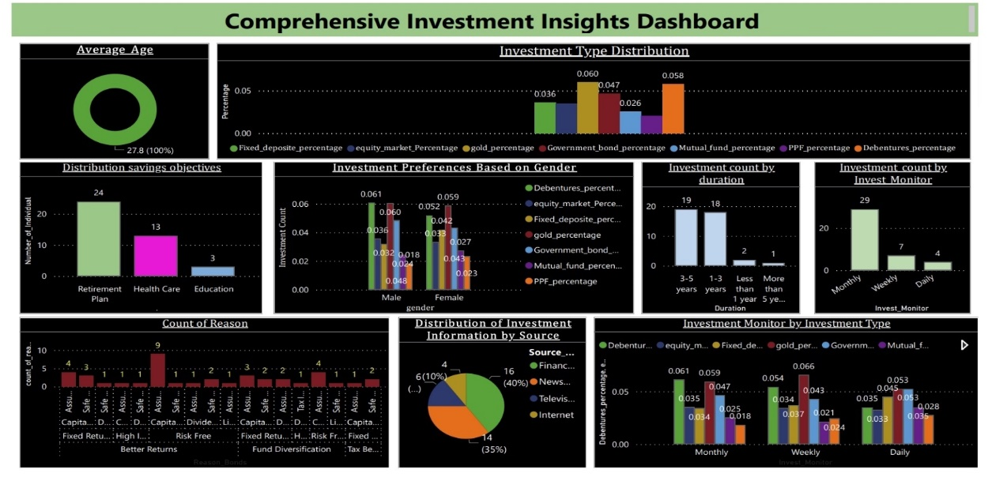

## **3. Tools and Technologies**

* **Power BI** for data visualization
* **Excel/CSV** for data handling and initial analysis

## **4. Skills Demonstrated**

* **Data Visualization:** Advanced Power BI techniques
* **Data Analysis:** Statistical and trend analysis
* **Insight Communication:** Effective presentation of data insights

## **5. Key Learnings**

* Improved skills in transforming data into actionable insights.
* Gained experience in handling real-world data projects and presenting findings to stakeholders.

## **6. Attachments**

**Dashboard Walkthrough Video:**

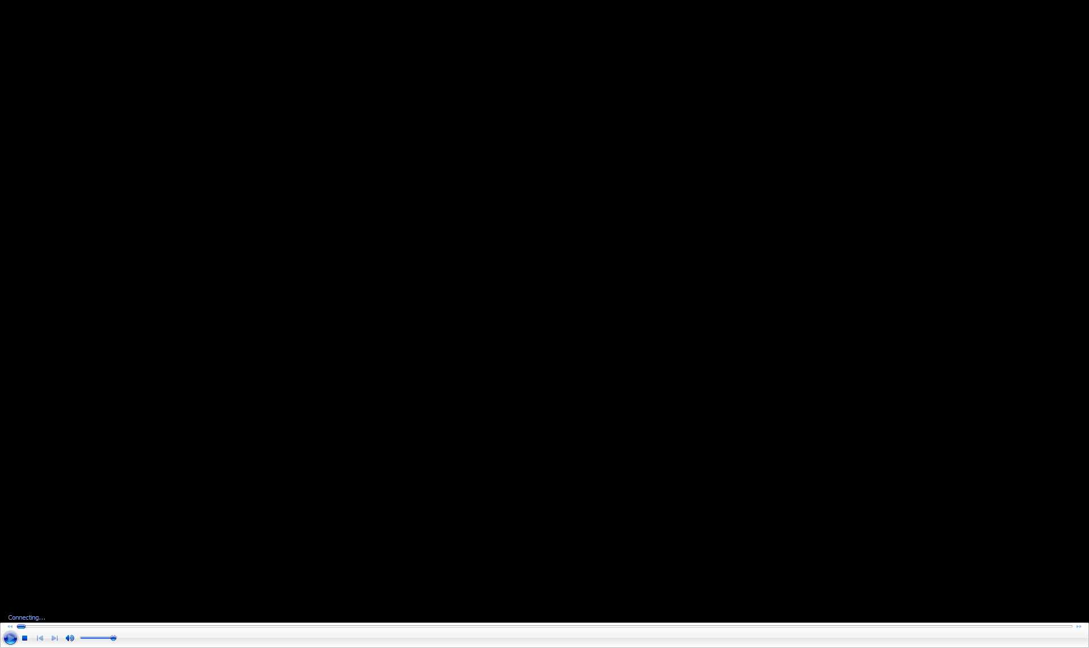

* **Dataset Description:** [**dataset_link**](https://drive.google.com/drive/folders/1WYhSn6FEt7riJ5EQhfJ8sqpzb5DDH4aW)